Yaruka irunthalum rmba naal palagita aprm bore adikatha ma seiyum pudhusa peasa ethum illa nu excitement kammi aagatha seiyum pudhusa peasuravanga kuda adhu nerayavey tha irukum aana yosichu paru athey madiri tha starting unakhu bore adichavangalum exiting ha irunthurupanga . . Pudhusa varavangalum oru tym ku aprm bore adichiruvanga

Apoyum namba lover ha choose pandrathula than lovey theriyum aana ne easya na bore adichiten mathatha thedi poidura epovum

Na seiya soli ketathulam avlo onum periya vishayamum illa atha pandrathu unakhum entha oru keshtamum illa epo intha prechana varutho apo tha ithelam thapa theriyum . . Ne mature ave illama inum kuda . . Character set aagala nu soldriye last antha 3 months illana neeye unakhu na than crctu nu solitu irupa

Ne en kita sonathulam maranthurupa aana na marakala apo apo eduthu vera pathutu iruken . . Adhanala than ne avlo en manasa odachum marubadi marubadi un kitaye varen

Na ne panathuku react panathula thapu irukunu ne ivlo panitu iruka aana na kova padrathuku ne evloo paniruka . . Kovathula thiti athula hurt aaguratha vida adikadi poi solli emathi loyala honest illama konjo kuda enna pathi yosikama ellam panitu poi soli hurt aagurathu evlo valikhum theriyuma

Unna vida enakhu tha seriousa neraya vali aana ne ellamey smootha pana na react panathu oreydiya adicha madiri iruku . . Ne ithuku enna vitu pooi ena ivlo keshta paduthi ipo enakhu pudikathathulam panikitu mothama mari iruka . . Na avlothayum thali vechitu un kita tha odi varen

Ipo ne marubadiyum vandhalum kandipa sanda poduven . . Ithana naala ne rmba vera madiri irunthuruka athukula na kekurathu unakhu pudikathu sanda varum kandipa 2ndu perum hurt aagum aluvok elam nadakum aana ithu nadantha tha athuku aprm sandhoshama irupom . . Temporarya itha avoid pana aprm perusa poitha mudiyum

Kandipa neraya sanda varum than aana na kovathula varthaiya vitu keshta padutha maten ithu un mela en amma mela sathiyam .. ithu varaikhum intha vishayathula na try pandrenu than soliruken ne ethum kova paduthura madiri panama iruntha na en kovathula vartha vida porenu soli ipo na promise pandren neeyum kova paduthama irukanum

Porala poitu pora furure la varavan edachu soluvan apo aven sonathu sarithan ,avan kudaye irunthurukalam ,avaney mel apdinu thonum patta than theriyum apdinumlam enala iruka mudiyathu . . Yara irunthalum edachu mathikitu irunthu tha ma aaganum . . Ne soana par na edhayum mathika maten ipdi than irupen ok nha love panalam nu munadiye solirukanum nu atha na acceptey panika maten . . Ipo iruka paru apdi tha irupen therinchiruntha un side ey vanthuruka maten athu vera vishayama . . Ipo ne soldra madiriye yarachu irukanga nu vechipom apo neeyum avanga kita edhayum mathikanum nu expect pana mudiyathu apo aven ena keta palakam vena vechikalam yaru kuda vena epdi vena suthalam irukapo unakhu podikalanaluk keka mudiyathu apo ena panuva divorce panuviya apo etha pera divorce panuva . . Elarumey ethayachu mathikitu irunthu tha ma aaganum yarum perfect illa. . Ne soanathu crct than nenum perfect illa aana unmaiya irukathula . .en pondatiya thavira entha ponnu melayum interest illama irukathula ena vida perfect evanum iruka mudiyathu. . Aprm na soldratha vida pasanga rmba mosam enakey ipo tha neraya theriyuthu soana avloo kevalama irukum suma veliya periya uthama madiri palaguranunga nu lam vida kudathu athanala tha na unna peasa venam nu soluven na unna yar kudayum share panika mudiyathu

Namba ipo elathulayum sari panitu onna irunthalum una velaikhu pogathanulam sathiyama sola maten kandipa veetla adachi vekirathulam enakhu pudikathu . . Aana kandipa boys iruka velai venam nu soluven . . Ithu varaikhum pasanga vishayathula vantha prechanalam pothum . . Insta la tha pakureney mela kaiya potukutu thadavikitu mela ukathukutu konjikitu ooti kitu office ha illa bitu padama therla apdi iruku athum maximum medical coding vela pakura naainga tha thala vidhi. . Avloo kevalama unna vitu athanala prechana vanthu sanda vara kadha lam venam . . Kandipa pasanga iruka madiri velaikhu vida maten ne thirumba vanthalum

Treasure en avlo value va soluvangana adhu elarukum easya kedaikathu kadai la vikira gold ha vida treasure la iruka oru muthu ku value adhigama . . Ipo ne iruka paru athulam rmba worst ha un value va neeye korachikitu iruka naluku naalu . . Ne enoda treasure di un value va korachikatha . . Ne marubadiyum varalanalum andha madiri velaikhu pogatha . . Pasanga illadha illa ellam una vida rmba periyavangala iruka madiri edachu lab technician illa edachu government exam eluthi po illa teacher aayudhu ne vanthalum itha tha un kita solalam nu irunthen

Aprm ne nenaikira madiri lam na un familya pathi peasala ma . . Na pothuvavey pasanga kuda badwords la peasunalumey parent lam illukavey maten . . Ne intha madiri serious ha eduthupenu sathiyama nenaikala na suma generala soldra madiri soana ma . . Un familya disrespect pananum lam peasala ma ethum . . Na epdi lam yosichu vechirunthen theriyuma un family kuda apdi irukanum ipdi irukanum nu lam

Na munadilam yosichiruken un akka sila frnds nala than namakhula ipdi sila prechana lam varuthu . . Avanga pandratha lam pananum avanga soldratha seiyanum nu panidra aana athu enakhu epdi irukumnu yosika Matra . . Neraya vishayathula munadi ne avangala vida rmbavey better ha iruka nu yosichiruken aana ipo adikadi avangaley sila vishayathula paravala pola nee rmba mosama iruka nu tha thonuthu apdi than iruka ipolam

Na munadilam yosichiruken un akka sila frnds nala than namakhula ipdi sila prechana lam varuthu . . Avanga pandratha lam pananum avanga soldratha seiyanum nu panidra aana athu enakhu epdi irukumnu yosika Matra . . Neraya vishayathula munadi ne avangala vida rmbavey better ha iruka nu yosichiruken aana ipo adikadi avangaley sila vishayathula paravala pola nee rmba mosama iruka nu tha thonuthu apdi than iruka ipolam

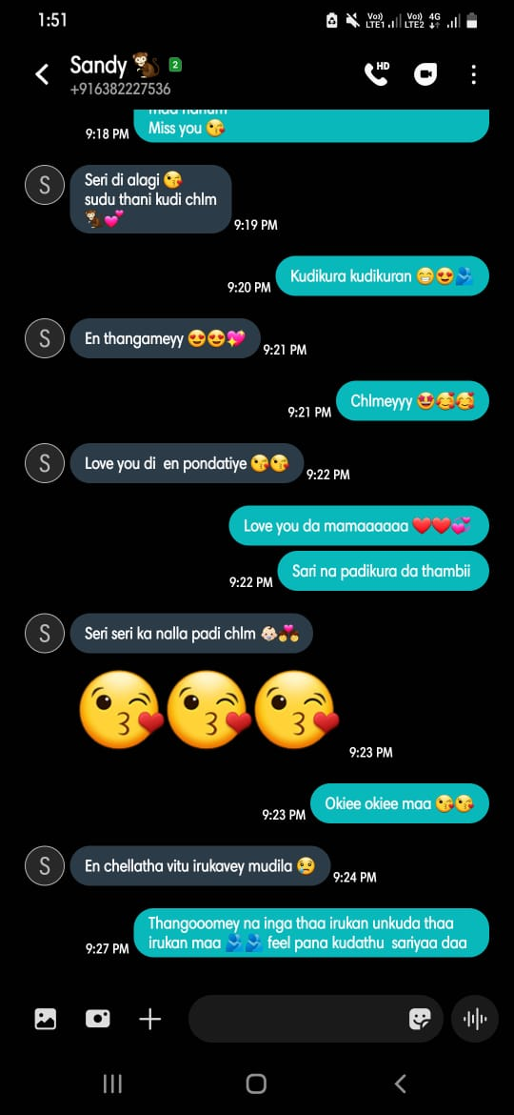

Ipo irukavala konjo kuda pudiakala ne ipdi tha nha enakhu ne enna vitu nallathu tha paniruka nu sandhoshama irunthurupen

Aana enakhu matum illa yaruka irunthalum intha madiri ponnu tha da venum nu soldra alavuku oru sweet ana rmba perfect ana super ana oru ponnu iruntha . . Ava epovum en chellakutty en pondati en devathai en ullagam tha avala madiri ne nadikala nu nalla theriyum . . Un kuda irukavanga unna suthi irukavangala than ne ipo ipdi iruka avanga epdi vena potum avangalam epovum apdi irukavanga avangaluku lam urugi urugi love pandraven illa enna madiri ena madiri una pathiye yosichikitu unna care panikitu unakhu alavuku athigama attention kuduthuku unakaga ena vena seirathuky oruthen iruka madiri oruthen illa epdiyo irukanga aana ne en chella pondati di avala ullaye sethuta nu ipdiye irukatha . . Avala enakhu kudu ava enakhu venum ma ava illaka ennala iruka mudiyathu ma